Step 1- Aeration

Background:

Aeration, the first step in the treatment process, adds air to water. It allows gases or volatile organic compounds (VOCs) trapped in the water to escape and adds oxygen to the water.
Aeration is used in the secondary treatment of sewage or industrial wastewater to increase DO (dissolved oxygen). A waste water treatment plant uses biological processes to remove toxic chemicals. An aerobic microbe, the thing that removes these toxic chemicals, needs oxygen in water to metabolize those toxic chemicals.
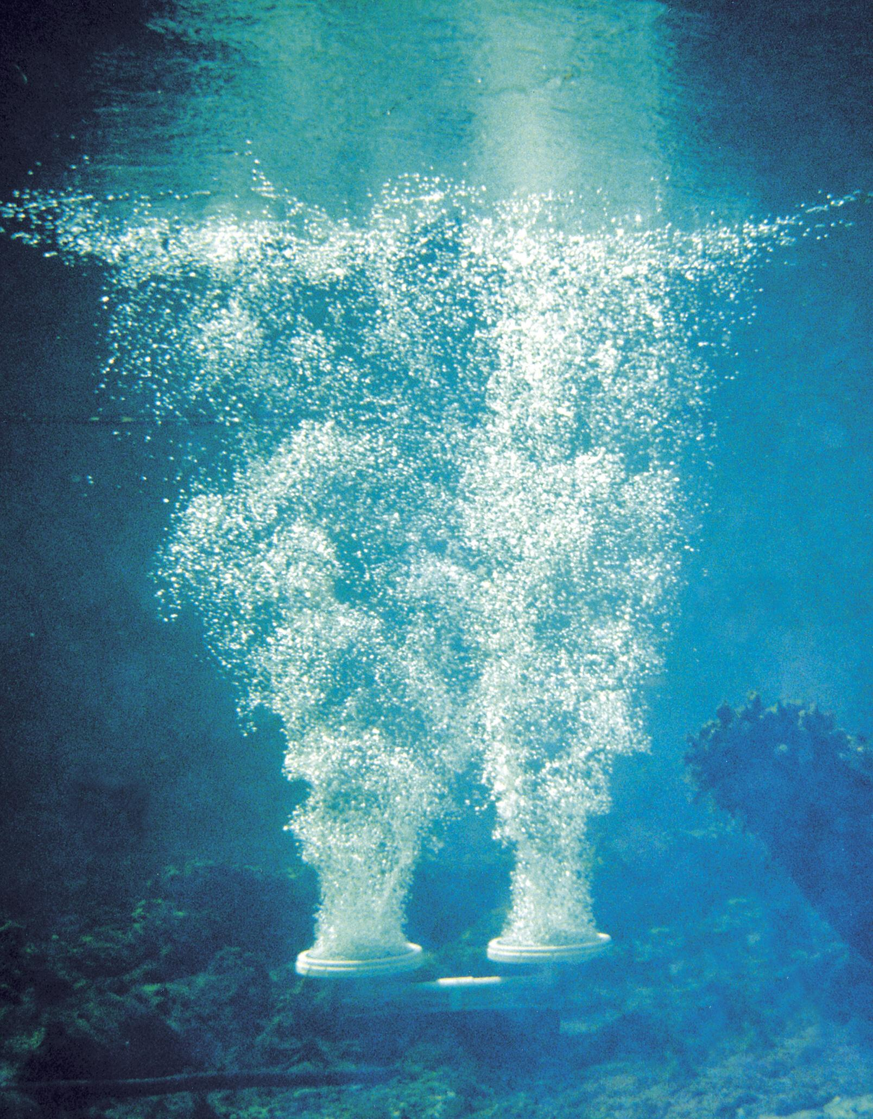

Procedure in Class:

1. Pour 1 L of swamp water into bottle
2. Place the cap on the bottle and vigorously shake the bottle for 30 seconds. Continue the aeration process by pouring the water into another bottle or the beaker, then pouring the water back and forth between them about 10 times. Once aerated, gases have escaped (bubbles should be gone). Pour your aerated water into your bottle with its top cut off.
Step 2- Coagulation

Background:

Coagulation is the process by which dirt and other suspended solid particles chemically “stick together” into floc (clumps of alum and sediment) so they can easily be removed from water.
Coagulation chemicals are added in water tank which "glue" small suspended particles together, so that they can be readily precipitate out or filtered.
One of the more common coagulants used is aluminum sulfate, sometimes called filter alum. Aluminum sulfate reacts with water to form flocs of aluminium hydroxide.

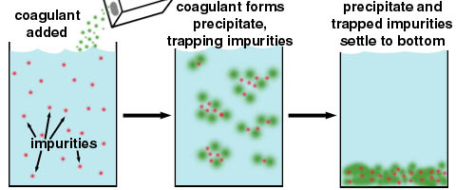

Procedure:

- Add two tablespoons of alum to dirty swamp water. Slowly stir the mixture for 5 minutes. You will see particles in the water clinging together to make larger clumps. This makes it harder for them to get through a filter at the plant and make particles heavier to easily settle down
Step 3- Sedimentation

Background:

Sedimentation is the process that occurs when gravity pulls the particles of floc to the bottom of the cylinder. As particles settle to the bottom of the tank a layer of sludge is formed on the floor of the tank.

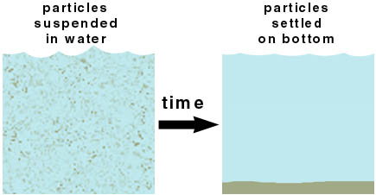

Procedure:

1. Allow the water to stand undisturbed in the cylinder. Observe the water at 1-minute intervals for a total of 5 minutes. Write down what you see - what is the appearance of the water now? At a treatment plant, there are settling beds that collect floc that floats to the bottom, allowing the clear water to be drained from the top of the bed and continue through the process.

Step 4- Filtration
Background
Filtration is the process of removing suspended solids from water by passing the water through a permeable fabric or porous bed of materials. Examples of filtration include a coffee filter which separates the coffee grounds from the brewed coffee; the use of consumer water filters to improve the taste or appearance of municipal water.
Procedure (Construction of sand filter)
Construct a filter from the bottle with its bottom cut off as follows (see illustration below)
1. Attach the coffee filter to the outside neck of the bottle with a rubber band.
- Turn the bottle upside down placing it in a beaker or cut-off bottom of a two-liter bottle. Pour a layer of pebbles into the bottle.
- Pour the coarse sand on top of the pebbles.
- Clean the filter by slowly and carefully pouring through 3 L (or more) of clean tap water.
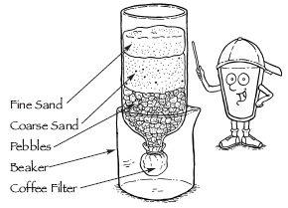
5. After a large amount of sediment have settled on the bottom of the bottle of swamp water, carefully - without disturbing the sediment - pour the top two-thirds of the swamp water through the filter. Collect the filtered water in the beaker. Pour the remaining (one-third bottle) of swamp water back into the collection container.

Step 5- Disinfection

Background

Disinfection is accomplished both by filtering out harmful micro-organisms and also by adding disinfectant chemicals. Water is disinfected to kill any pathogens which pass through the filters and to provide a small dose of disinfectant to kill or inactivate potentially harmful micro-organisms in the storage and distribution systems. Possible pathogens include viruses, bacteria, including Salmonella, Cholera, Campylobacter and Shigella, and protozoa, including Giardia lamblia and other cryptosporidia. Following the introduction of any chemical disinfecting agent, the water is usually held in temporary storage – often called a contact tank or clear well to allow the disinfecting action to complete.

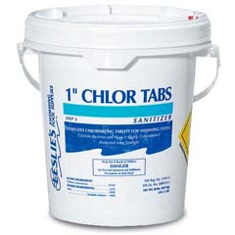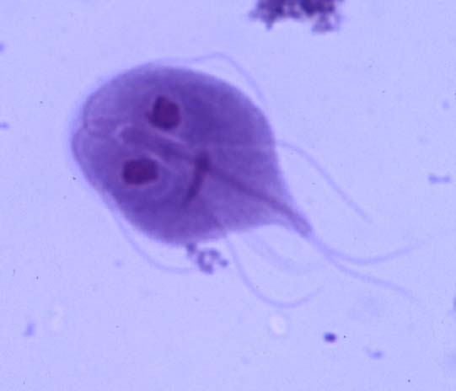
Chlorine Tablets Giardia lamblia

Procedure

Add chlorine or iodine to the water and mix.

Observations

Aeration

Coagulation

Sedimentation

Filtration Disinfection

Disinfection

